

**YEAR: 9**

**SUBJECT: SCIENCE**

**EXAM: Chemical reactions**

**TIME: 5 mins reading + 55 mins working time**

**QUESTIONS:**

**Part A: Multiple- Choice Questions (6 marks)**

**Part B: Short Answer Questions (35 marks)**

**TOTAL MARKS: 41 marks**

**DO NOT WRITE ON OR MARK THIS PAPER**

**SECTION ONE: Multiple Choice Questions (1 mark each)**

**Answer this section on the separate multiple – choice answer sheet**

1. The law of conservation of mass explains why, in a chemical reaction:
   1. energy cannot be created nor destroyed, only transformed or transferred.
   2. the total mass of reactants equals the total mass of products.
   3. new atoms are created from the reactant atoms.
   4. when rearranging atoms to form products, the mass changes significantly.
2. A chemical equation shows:
   1. the chemical formulas of the reactants and products.
   2. the names of the reactants and the products in words.
   3. all the atoms in the compounds of the reactants, but not the products.
   4. all the atoms involved in the reaction and how they rearrange into the products.
3. Copper reacts with sulfur dioxide to form copper sulfide and oxygen gas. The reactants for this reaction are:
   1. copper
   2. copper and sulfur dioxide
   3. copper sulfide and oxygen gas
   4. copper, sulphur dioxide, copper sulfide and oxygen gas
4. When petrol explodes, it releases energy in the form of heat and light. This reaction is an example of:
   1. an endothermic reaction
   2. an exothermic reaction
   3. a neutralisation reaction
   4. an extrathermic reaction
5. Neutralisation reactions between acids and bases can be generalised by which one of the following word equations?
6. acid + base → hydrogen gas + salt + water
7. acid + base → water
8. acid + base → salt + water
9. acid + base → salt + carbon dioxide + water
10. Which of the following chemical equations is correctly balanced?
    1. HCl + NaOH → NaCl + H2O
    2. H2 + O2 → H2O
    3. 2Na + H2O → 2NaOH + H2
    4. CaCl2 + PbCO3 → 2PbCl2 + CaCO3



**SCIENCE EXAM**

**SEMESTER TWO 2017**

**Chemical reactions:**

**ANSWER BOOKLET**

**NAME:**

**FORM:** **DATE:**

Multiple Choice Short Answer Total

**/41**

**/35**

**/6**

**SECTION ONE:** Multiple choice answers

Cross (X) through the correct answer.

|  |  |  |  |  |
| --- | --- | --- | --- | --- |
| 1 | a | b | c | d |
| 2 | a | b | c | d |
| 3 | a | b | c | d |
| 4 | a | b | c | d |
| 5 | a | b | c | d |
| 6 | a | b | c | d |

**SECTION TWO: Short Answer (35 marks)**

Answer the questions in the spaces provided.

**Question 5 (4 marks)**

Ethane (C2H6) reacts with oxygen gas (O2) to form carbon dioxide (CO­2) and water vapour (H2O).

1. **Identify** the reactants of this reaction.

1. **Identify** the products of this reaction.

1. **Construct** a word equation for this reaction.

1. **Construct** an unbalanced formula equation for this reaction.

**Question 6 (5 marks)**

Magnesium burns in oxygen gas to form magnesium oxide. Its unbalanced formula equation is:

Mg + O2 → MgO

1. Use this equation to **identify** the chemical formula for magnesium oxide.

1. **Construct** a word equation describing this reaction.

1. **Identify** which element (Mg or O) is unbalanced in the above equation.

1. **Balance** the equation and re-write it below.

1. **Identify** the type of reaction that has taken place.

**Question 7 (4marks)**

**Balance** the following chemical equations:

1. 
2. 
3. 
4. 

**Question 8 (4 marks)**

The graph below shows the change in energy that occurs during a chemical reaction.

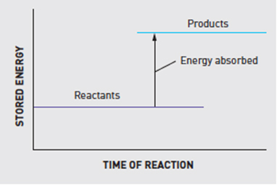

1. Is this an endothermic or an exothermic reaction? (1 mark)

1. Explain why you chose your answer for part a) above. (2 marks)

1. Where does the energy that is released in an exothermic reaction come from? (1 mark)

**Question 9 (4 marks)**

Match the names of the following acids and bases to their correct chemical formulas.

|  |  |
| --- | --- |
| ***Word Bank:* sodium hydroxide, hydrochloric acid, ammonia, sulfuric acid, HCl, NH3, H2SO4, NaOH** | |
| **NAME** | **CHEMICAL FORMULA** |
|  |  |
|  |  |
|  |  |
|  |  |

**Question 10**

Acids are commonly found around us. Bases can be described as the ‘chemical opposite’ of acids.

1. List the main properties of **acids** and **bases**. **(4 marks)**

|  |  |
| --- | --- |
| **ACIDS** | **BASES** |
|  |  |
|  |  |
|  |  |
|  |  |

1. What is the difference between a strong and a weak acid? (**2 marks)**

**Question 11 (5 marks)**

Use this graph to answer the following questions:

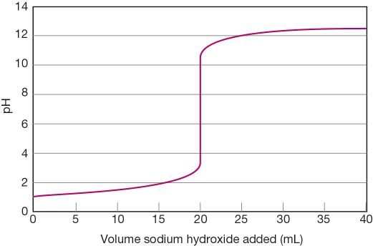Increasing volumes of sodium hydroxide (NaOH) were added to a solution of hydrochloric acid (HCl). As it was added, the pH changed according to the graph shown below.

1. State the pH of the solution at the start of the experiment.

1. Determine the volume of sodium hydroxide that is needed to be added to exactly neutralise the acid.

1. Determine the pH when 16 mL of sodium hydroxide was added.

1. Determine the total volume of sodium hydroxide added in the experiment.

1. At the end of the above experiment, what type of solution (acidic or basic) was formed?

**Question 12 (3 marks)**

The resulting colours of indicators at different pH levels is shown below:

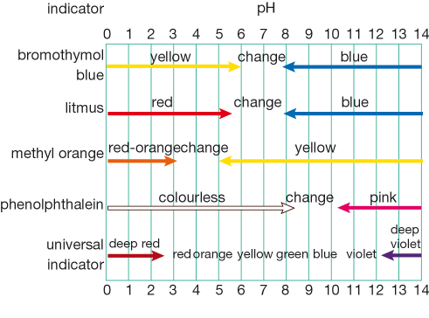

1. The pH of an acidic solution is 4. What colour would you expect the solution to be if tested with **universal indicator?**

1. An unknown solution was tested with different indicators to determine its pH. The results of these tests are shown in the table below:

|  |  |
| --- | --- |
| Indicator | Result colour |
| bromothymol blue | yellow |
| litmus | red |
| methyl orange | yellow |

Using the table AND the diagram above, what is the most likely pH level (or range of pH levels) for this solution?

1. The pH of a swimming pool always needs to be between 7.4 and 7.6. Is this pH range **acidic, neutral** or **alkaline**?



**END OF EXAM**

Please go back and check your work /

complete any unanswered questions.